Chapter 15 Name:____________
Energy Mr. Rosener
Chapter 15 Pre-Test

1. How much work is done when a
weightlifter holds a barbell motionless
over his head?

2. Calculate the work done on a 2-N mass
when it is lifted to a height of 2 m.

3. Calculate the average speed of a bicycle
that travels 100 m in 20 s.

4. Is weight a force? What is the formula for calculating weight?

5. How does the temperature of an object change when it is acted on by friction?

6. True or False: In a closed system, the loss of momentum of one object equals the gain in momentum of another object.

Section 1: Energy and Its Forms
Energy and Work
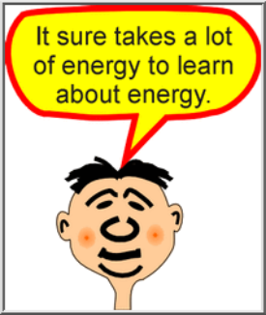
- Energy is the __________ to do work.
- In other words, energy is transferred by a ________ moving an object through a ___________.
- When work is done on an object, energy is ___________ to that object.
- Both work and energy are typically measured in _______________
Kinetic Energy
- The energy of _____________
- The kinetic energy of any moving object depends upon its ___________ and _______________.
- Formula:


A 70.0-kilogram man is walking at a speed of 2.0 m/s. What is his kinetic energy?

A 1400-kilogram car is moving at a speed of 25 m/s. How much kinetic energy does the car have?

A 50.0-kilogram cheetah has a kinetic energy of 18,000 J. How fast is the cheetah running? (Hint: Rearrange the equation to solve for v.)

Kinetic Energy
- Notice that doubling the ___________ in the formula would double the __________ energy. However, doubling the ___________ would _______________ the kinetic energy, since kinetic energy is proportional to the square of an object’s speed.

Potential Energy
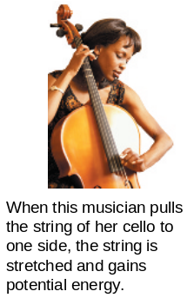
- energy that is __________ as a result of position or shape.
- Two forms of potential energy are ___________________ energy and __________________ potential energy.

Gravitational Potential Energy
- Potential energy that depends upon an object’s _____________  - An object’s gravitational potential energy depends on its ________, its ___________, and the _________________ due to gravity.  - Formula: | 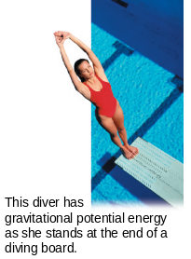
Elastic Potential Energy
- The potential energy of an object that is ____________ or ___________________.
- Something is said to be elastic if it ___________ back to its ____________shape after it is stretched or compressed.
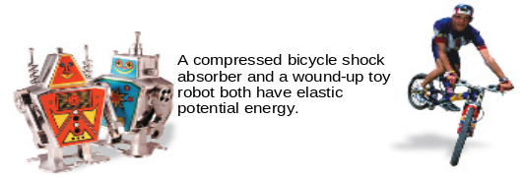

Forms of Energy
- All energy can be considered to be ___________ energy, ____________ energy, or the energy in _____________ such as those produced by electromagnetic waves.

The major forms of energy are mechanical energy, thermal energy, chemical energy, electrical energy, electromagnetic energy, and nuclear energy.

Mechanical Energy
- The energy associated with the ___________ and __________ of everyday objects

- Mechanical energy is ______ limited to machines.
- Mechanical energy is the ____________ of an object’s potential energy and kinetic energy
- Speeding trains, bouncing balls, and sprinting athletes all have _______________ energy.
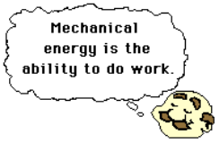

Thermal Energy
- Almost all of the matter around you contains _________.  - The ________ potential and kinetic energy of all the microscopic particles in an __________ make up its thermal energy  - When an object’s _______ move ____________, its thermal energy increases and the object becomes ___________ | 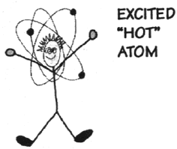  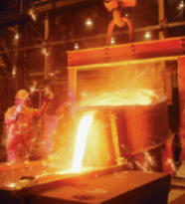
Chemical Energy
- the energy stored in _____________ bonds  - When bonds are ___________, the released energy can do ________.  - All chemical compounds, including ______ such as coal and gasoline, store ________. |   

Electrical Energy
- the energy associated with _______charges.  - Electric charges can exert ___________ that do __________.  - Electrical energy also occurs in _________.  - CD players, flashlights, and calculators. |   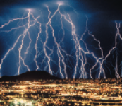
Electromagnetic Energy
- a form of energy that travels through space in the form of ___________.  - Visible light and X-rays  - Because electromagnetic waves can travel long distances through air and space, they are often used for ____________________. | 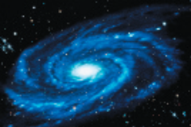  Galaxies are giant structures in space that typically contain billions of stars. The stars give off enormous amounts of electromagnetic energy
Nuclear Energy
- The nucleus of an atom is held together by strong and weak nuclear forces, which can store an enormous amount of _______________ energy.  - The energy stored in _________________ is known as nuclear energy.  - Nuclear fission is a process that releases energy by ____________ nuclei apart.  - Nuclear fusion, releases energy when less massive nuclei ____________ to form a more massive nucleus. | 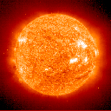  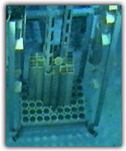  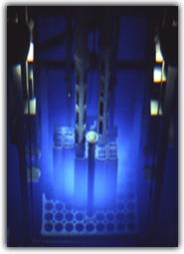

Section 2: Energy Conversion and Conservation

Energy Conversion
- Energy can be converted from one form to another.  - The process of ____________ energy from one form to another is energy conversion. | 
Conservation of Energy
- When energy changes from one form to another, the total energy remains unchanged even though many energy conversions may occur.
- The law of conservation of energy states that energy cannot be __________ or ________________.
Energy Conversions
- One of the _________ _____________ energy conversions is between potential energy and kinetic energy.
- The _______________ potential energy of an object is converted to the ___________ energy of motion as the object ________.
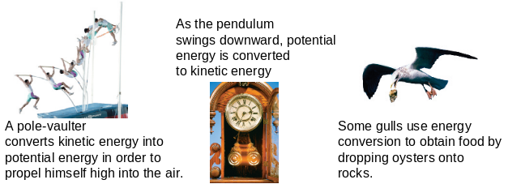

Energy Conversion Calculations
- When __________ is small enough to be ignored, and no mechanical energy is added to a system, then the system’s mechanical energy _______________ change.
- Energy Conversion Formula:


A 10-kg rock is dropped and hits the ground below at a speed of 60 m/s. Calculate the gravitational potential energy of the rock before it was dropped. You can ignore the effects of friction.

A diver with a mass of 70.0 kg stands motionless at the top of a 3.0-m-high diving platform. Calculate his potential energy relative to the water surface while standing on the platform, and his speed when he enters the pool. (Hint: Assume the diver’s initial vertical speed after diving is zero.)

A pendulum with a 1.0-kg weight is set in motion from a position 0.04 m above the lowest point on the path of the weight. What is the kinetic energy of the pendulum at the lowest point? (Hint: Assume there is no friction.)

Energy and Mass
- Physicist Albert Einstein (1879–1955) developed his special theory of _________________ in 1905.  - Einstein’s equation, E = mc2, says that _________ and ________ are equivalent and can be converted into each other.  - In Einstein’s equation, E is energy, m is mass, and c is the speed of light. | 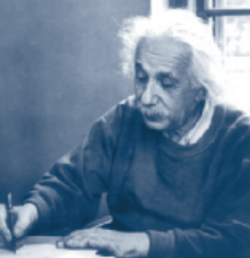

Section 3: Energy Resources

Nonrenewable Energy Resources
- Nonrenewable energy resources exist in _____________ quantities and, once used, ________ be replaced except over the course of _____________ of years.  - Nonrenewable energy resources include oil, natural gas, coal, and uranium. | 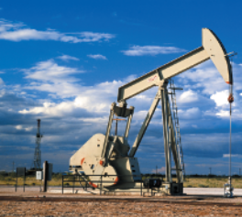

Renewable Energy Resources
- Renewable energy resources are resources that can be ____________ in a relatively _________ period of time.
- Renewable energy resources include hydroelectric, solar, geothermal, wind, biomass, and, possibly in the future, nuclear fusion.
Hydroelectric Energy
- Energy obtained from flowing __________ is known as __________________ energy.  - As water flows downhill, its _________________ potential energy is converted into _____________ energy.  - This ___________ energy can be used to turn turbines that are connected to electric generators | 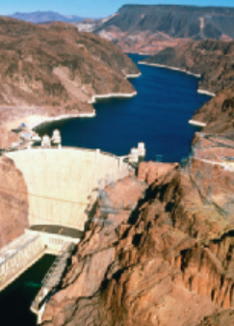
Solar Energy
- ____________ that is converted into usable energy is called ___________ energy.  - Passive solar designs use sunlight to heat a building without using machinery.  - Sunlight can also be converted directly into electrical energy by means of solar cells, also known as __________________ cells. | 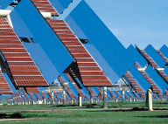
Geothermal Energy
- Geothermal energy is thermal energy beneath ____________ surface.  - Geothermal energy is _________________, but is ______ widely available.  - Near _______________, geothermal energy is used to generate electricity. | 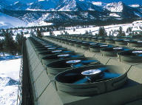
Other Renewable Resources
- Sunlight causes plants to grow, __________ electromagnetic energy into chemical energy. The chemical energy stored in living things is called _____________ energy. Biomass can be converted directly into _______________ energy.
- A hydrogen fuel cell generates electricity by reacting hydrogen with oxygen. __________ fuel can be extracted from water using electricity from solar cells. The end product of fuel cells is ___________, so they offer a nonpolluting means for transporting energy.

Conserving Energy Resources
- Energy resources can be conserved by __________ energy needs and by increasing the _____________ of energy use.
- Finding ways to use less energy or to use energy more efficiently is known as ________ _________________.

